Day of the Week | ELA MUST DO –  30 Minutes Each (Graded) | ELA CAN DO –  Optional (Not Graded)
Monday | Reading Comprehension  - Read a book of your choice (can be either fiction or nonfiction).  - Choose 3 Reading Comprehension Questions to answer about your book by looking on the Digital Learning website under “Resources.”  - Submit on via Seesaw. | iReady Reading – on ANY DEVICE  - Log in to FCS Launchpad using the link on the Digital Learning website under “Links for Assignments.”  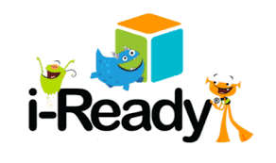  - Put your username & password in the boxes (don’t forget to put “Fulton” in the code box, if it asks).  - Lastly, click on the iReady icon.  - Begin the lesson on which you left off.
Tuesday | 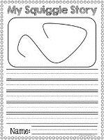  Squiggle Story  - Print your choice of a squiggle by looking on the Digital Learning website under “Resources.”  - Turn the squiggle into a character and write a story about it! Don’t forget to include a beginning, middle, and end!  - Submit via Seesaw. | Daily Journal  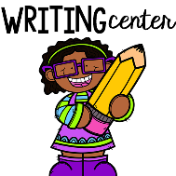  - Write about your Digital Learning experience! What have you done? What have you liked? Disliked?  - Have you done anything fun outside of your Digital Learning time? I would love to hear all about it!  - Writing paper can be found on the Digital Learning website under “Resources,” if needed.  - Share on Seesaw if you have time.
Wednesday | Pebble Go  - Login to Pebble Go by using the link on the Digital Learning website under “Links for Assignments.”  - Put the username & password in the boxes that was given to you by your teacher.  - Search “George Washington Carver.”  - Complete the corresponding activity page (look on the Digital Learning website under “Resources” for directions on how to access).  - Submit via Seesaw. | Pebble Go  - Login to Pebble Go by using the link on the Digital Learning website under “Links for Assignments.”  - Put the username & password in the boxes that was given to you by your teacher.  - Choose any of the topics underneath the link.  - Complete the corresponding activity page (look on the Digital Learning website under “Resources” for directions on how to access).  - Share on Seesaw if you have time.
Thursday | Squiggle Story  - Print your choice of a squiggle by looking on the Digital Learning website under “Resources.”  - Turn the squiggle into a character and write a story about it! Don’t forget to include a beginning, middle, and end!  - Submit via Seesaw. | 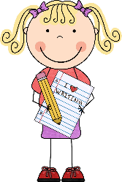  Free Writing  - Choose a writing style – narrative, informational, or opinion.  - Free write about anything on one of these topics!  - Writing paper can be found on the Digital Learning website under “Resources,” if needed.  - Share on Seesaw if you have time.
Friday | Reading Comprehension  - Read a book of your choice (must be a FICTION book).  - Complete the Reading Response Questions about your book by looking on the Digital Learning website under “Resources.”  - Submit via Seesaw. | Spring Story QR Codes  - View the March and April story QR codes by looking on the Digital Learning website under “Resources.’  - Print the corresponding pages for the story you chose and complete them.  - Share on Seesaw if you have time.

